Project No.

Project Name

CONTENT

Section Description

PREAMBLES Introduction............................................................................
Project Details.........................................................................
Description of Contents .........................................................
Services Abbreviations.............................................................
Services Identification.............................................................
Use of the Manual....................................................................
Manual Update Procedure.......................................................
Revision Status.........................................................................

ONE ............................. INTRODUCTION ..............................................................................1/1

TWO ............................ DESCRIPTION OF WORKS.................................................................2/1

THREE..........................Maintenance Procedures..................................................................3/1

FOUR ...........................MANAFACTURERS DIRECTORY.........................................................4/1

FIVE ............................. TECHNICAL LITERATURE .................................................................5/1

SIX................................ COMMISSIONING DATA ..................................................................6/1

SEVEN.......................... RECORD DRAWINGS…...................................................................7/1

INTRODUCTION

The purpose of this manual the manufacturer’s technical literature and the record drawings is to offer the personnel concerned with the operation and maintenance of the mechanical services.

The purpose of this manual, the manufacturers' technical literature and the record
drawings is to offer the personnel concerned with the operation and maintenance of the
mechanical services within the building maximum assistance in the performance of their duties.

The manual has been prepared on the assumption that a competent person will be charged with the responsibility of the mechanical services.

Although the manual functions as a complete entity, each section is self-contained and provides information on differing aspects of the installation. Familiarisation with all sections prior to formulating operating and maintenance programme will prepare the building management personnel for the occasions when a particular problem occurs.

Each section of the manual is written in the same building block and system order and where possible sub-sections within each main section utilise the same code numbers. It should be noted that a planned schedule of inspection and repair, together with familiarisation of the plant on site by the qualified Maintenance Personnel is the heart of a preventative maintenance programme.

The operating and maintenance recommendations provided in this manual are based on best industry practices. These are not designed to be a replacement for specific manufacturer’s recommendations. Further advice should be sought in the manufacturers.
O&M Manuals for specific conditions that may affect product or system warranty. COMPANY NAME accept no liability for any loss, damage or personal injury associated with the recommendations in this manual.

PROJECT DETAILS

Project Title:

Month of Completion:

Main Contractor:

MECHANICAL LIST OF ABBREVIATIONS

QUANTITY TYPE ABBR. UNITS

FLOW RATE Mass kg/s Kilogrammes per second
Volume m³/s Cubic metres per second
l/s Litres per second

MOTION Velocity m/s Metres per second
Frequency Hz Hertz (one cycle per second)
Rotational rpm Revolutions per minute frequency

PRESSURE N/m²(Pa) Newtons per square metre (Pascal)
kN/m² Kilonewtons per square metre
(kPa) (Kilopascal)
mmwg Millimetres water gauge
bar Bar

TEMPERATURE °C Degrees Celsius (Centigrade)
HEAT kW Kilowatts
POWER Motor power kW Kilowatts
ELECTRICITY State ph Phase
Potential V Volts
Current Amp Ampere
Equipment TP&N Triple pole and neutral
DP Double pole SP Single pole

USE OF THE MANUAL

Competent Personnel

The operating and maintenance procedures described in this manual are to be carried out only by competent personnel with a thorough knowledge of the systems installed and the hazards involved.

Any instructions provided by the authors, (End Systems Limited) are based on best practice, industry standards and equipment manufacturer's recommendations. Accordingly, End Systems Limited accept no responsibility for any losses or damage to plant, equipment buildings or personnel as a result of the execution of any procedures published in this manual.

Removal of Information

Although the information in this manual is filed loose leaf, due consideration should be given to others who may need to use the manual and therefore, information should not be removed for any period of time.

Warnings

It should be remembered that with remote controlled systems various items of
equipment may become energised without warning. It is therefore imperative to ensure that any item of equipment is electrically isolated before maintenance work is carried out.

When working on gas fired appliances, ensure gas supplies are isolated and the areas are well ventilated.

When working with hazardous substances, the relevant COSHH regulation sheet for
materials handling should be adhered to.

MANUAL UPDATE PROCEDURE

Once the final issue manuals have been issued, the personnel tasked with holding the
information should be identified below, and all other columns completed.

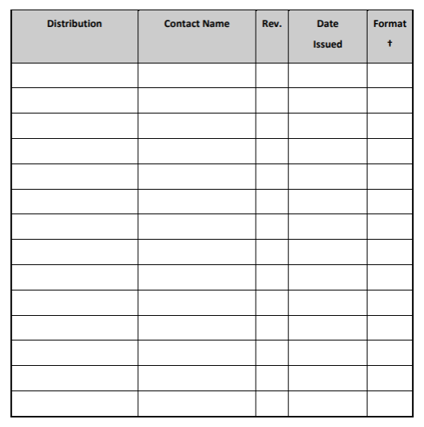

REVISION STATUS

The following table provides for a revision history, and MUST be completed when the
manuals are periodically updated. Any building changes should be held in a central point.
If required, these can be issued to the original authors, COMPANY NAME

